UNIT 7: TRAFFIC
PART 1. PHONETICS
1. Find the word which has a different sound in the part underlined. Read the words aloud.
1. A. wet B. met C. head D. hand
2. A. girl B. burn C. turn D. pearl
3. A. left B. debt C. fan D. dead
4. A. train B. tale C. mine D. rain
5. A. die B. bicycle C. high D. min
6. A. meet B. feed C. speed D. fit
7. A. limit B. lipid C. treat D. hit
8. A. curve B. term C. gear D. herm
9. A. truck B. drunk C. mug D. dark
10. A. sign B. light C. bye D. tin
2. Put the words with the underlined part in the box into two groups.
train young helicopter left
video plane rain tour
railway late southern does
station dead grey shoulder
head no wet road
/eɪ/ | /ɛ/

3. Label the signs with the words/phrases below.
Danger Railroad Crossing Right Lane Ends
No Trucks Right Turn Ahead
Right Curve Ahead Watch Children
Emergency Vehicle Warning No Pedestrian Crossing

a. | e.  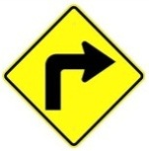
b.  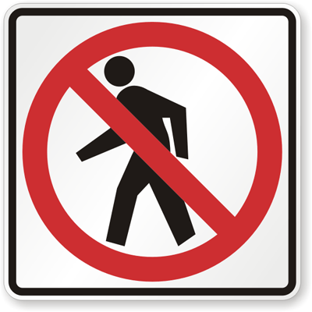 | f.  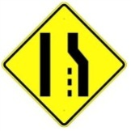
c.  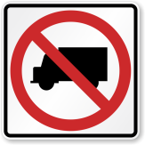 | g.  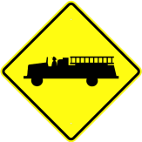
d. | h.  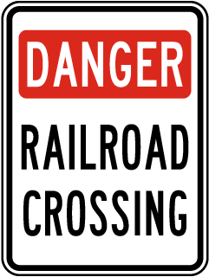
PART 2: VOCABULARY & GRAMMAR
1. Circle A, B, C or D for each picture.
1.  A. Maximum speed is 5.  B. Minimum speed is 5.  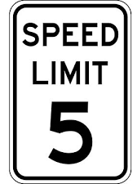  C. Only 5 MPH is allowed.  D. Speed limit is lower than 25 MPH. | 4.  A. You can buy cattle meat here.  B. There are cattle ahead.  C. There are wild animals ahead.  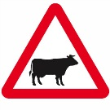  D. Cattle are not allowed.
2.  A. Cars cannot be sold here.  B. Cars and trucks can pass.  C. Cars are not allowed.  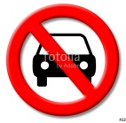  D. Bicycles are not allowed. | 5.  A. Bullying is allowed.  B. Bully may be arrested.  C. Bullying must be stopped.  D. This zone is dangerous.
3.  A. You cannot return.  B. Go ahead isn't allowed.  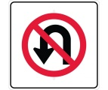  C. You must return.  D. Watch out the pedestrians. | 6.  A. Cameras are used here.  B. You can't use your camera here.  C. Cameras are sold ahead.  D. Take photograph when crossing road.
2. Find one odd word A, B, C or D.
1. A. train B. plane C. plant D. car
2. A. left B. right C. straight D. square
3. A. green B. red C. orange D. light
4. A. drive B. write C. ride D. fly
5. A. fast B. rapid C. slow D. quick
3. Put questions for the underlined parts in the following sentences, using question words in brackets.
1. Nam usually goes to school by bus. Sometimes, he rides his bicycle. (How)

2. My grandfather used to go fishing in the West Lake every afternoon. (What)

3. There are a lot of trucks and cars on the highway in the rush hour. (Where)

4. The students used to be taught about road signs when they studied in secondary school. (What)

5. Hung always drives his car very carefully. (How)

6. It is about 100 km from Ha Noi to Hai Phong. (How long)

4. Fill each blank with suitable words in the box.
am is are used to use to it from
to catches walked ride jam station
1. Mai driving her car to her office.
2. How far it from your home to your school?
3. You will get stuck in a traffic if you go outside in the rush hour?
4. He usually on foot to school when he was a child.
5. you in hurry?
6. Did you go swimming on the lake near your house, Tuan?
7. Lana comes USA. She was born in a well-known family.
8. My dad the bus to work every morning, but Mom drives.
9. John used to immigrate Brazil. Have you ever been there?
10. I participating in a volunteer trip to Lang Son. A lot of families are living in poor conditions.
11. is not very far from here to the warehouse.
12. I must go to railway to catch a train to my motherland.
5. Complete the following conversation with the sentences A-F.
Burt: Why didn't you show up for class this morning?
Kevin: I don't even want to talk about it. .
Burt: ?
Kevin: The engine seems to be busted. !
Burt: Wow. Have you thought about getting a new car?
Kevin: Yeah, I've thought about that, .
I'm broke.
Burt: Maybe you can lease a car. .
I know Toyota is running a promotion.
Kevin: Really? How much is it?
Burt : .
Kevin: That's a good deal. I might want to consider it.
A. My car broke down | D. It doesn't cost much
B. It's driving me crazy | E. but I can't afford a new car
C. Zero down and $219 per month | F. What happened

6. Give the correct form of the words in brackets.
Traffic jam (to be) a common sight in big cities like Delhi, Mumbai,Calcutta etc. This is due to (increase) population of the metropolitan cities.People from far off places rush towards big cities to (earn) as big cities (have) many options and possibilities for them. Then there are permanent citizens also. So with the human traffic, vehicular traffic also increases. As the standard of living is (become) high everyone wants to (purchase) his own car.
PART 3: READING
1. Fill in the blank with a word/ phrase in the box.
trains discourage transport expensive
example problem cities pollution
Traffic congestion in many (1) around the world is severe. One possible solution to this (2) is to impose heavy taxes on car drivers and use this money to make public transport better. One of the first benefits of such a measure is that the heavy taxes would (3) car owners from using their cars because it would become very (4) to drive. This would mean that they would begin to make use of public (5) instead, thus reducing traffic problems and (6) as well. Another benefit would be that much more use would be made of public transport if it was improved. It is often the case that public transport in cities is very poor. For (7) , we often see old buses and (8) that people would rather not use. High taxes would generate enough money to make the necessary changes.
2. Read the passage and answer the questions.
The first traffic control device appeared near the British House of Parliament at the intersection of George and Bridge Streets. The device was made in response to the desire by a Select Committee to use railway signals on highways. The device had lights and it used arms which extended outwards. It was operated manually by a police officer. The signal was 22 feet high and crowned with a gas light. The light was called semaphore and had arms that would extend horizontally that commanded drivers to "Stop" and then the arms would lower to a 45 degrees angle to tell drivers to proceed with "Caution". At night a red light would command "Stop" and a green light wouldmean use "Caution".The man behind this new and different invention was John Peake Knight a railroad engineer. The main reason for the traffic light was that there was an overflow of horse-drawn traffic over Westminster Bridge which forced thousands of pedestrians to walk next to the house of Parliament. But Knight's invention was not to last long. After only a month of use the device exploded and injured the police officer who was operating the light. In the first two decades of the 20th century semaphore traffic signals, like the one in London, were in use all over the United States with each state having its own design of the device. One good example was from Toledo, Ohio in 1908. The words "Stop" and "Go" were in white on a green background and the lights had red and green lenses illuminated by kerosene lamps for night travelers and the arms where eight feet above ground. Controlled by a traffic officer who would blow a whistle before changing the commands on this signal to help alert travelers of the change, the design was also used in Philadelphia and Detroit. The example in Ohio was the first time America tried to use a more visible form of traffic control that evolved the use of semaphore. The device that was used in Ohio was designed based on the use of railroad signals.
1. What was the main purpose of making the first traffic control device?

2. What was the light operated manually by a police officer called?

3. Why wasn't John Peake Knight's invention to last long?

4. How tall were the arms of the traffic lights used in Ohio in 1908?

5. The Westminster Bridge is in .
A. America B. England C. Brazil D. Canada
3. Read the passage and put a suitable word in each of the gaps.
Traffic jams in Vietnam only frequently take in Hanoi capital and Ho Chi Minh City. Vietnamese people seem to be accustomed to traffic congestion, even miss it whenever they go to other places. There is no fixed rule for the the traffic jams to happen but is worst during the rush hour when everyone is in a hurry to get to work or come back home. Apart from peak hours, the time between 9 am and 10 am and between 3 pm and 4 pm also witnesses long lines of vehicles, mainly motorbikes, struggling to get of narrow streets.
Whenever it rains, the traffic jam gets more terrible with the joining hand offlooding. Taxis are extremely hard to or wave during the downpour. However, it only about 30 minutes on average for a standstill and 2 hours to get through the worst, not really bad compared to that of other countries.While the rapid increase in car use coupled with the deterioration of roads caused by disordered planning make the matter worse, the most annoying thing about the traffic jam the way people react when being at the congestion. Most road users ride their motorbikes on the pavement rather than waiting calmly, or they constantly use their horns to hasten riders in the front, even shouting at them from time to time. More luckily, bicyclists can leisurely carry their "war-horses" on their backs and thread their way through messy matrixes.
PART 4: WRITING
1. Make sentences using the words and phrases given.
1. Mr Thanh/ didn't/ to/ travel/ Korea.

2. It/ 250 km/ Ho Chi Minh City/ Da Nang.

3. My hometown/ used to/ small village.

4. How/ it/ Ha Noi/ Singapore/ past?

5. Lana/ use to/ on foot/ school/ or/ car?

6. He/ used/ good/ student/ but/ now/ poor.

2. Rewrite the following sentences so that their meaning stays the same, using the word given for each.
1. My father is always a careful driver. | DRIVES
2. The distance from Ha Noi to Hai Phong is about 100 km. | IT
3. Be careful or you'll have an accident. | IF
4. Hung went to his homeland by train some years ago, but now he drives his car. | USED
5. Road users should obey traffic rules strictly. | OBEYED
6. Is it possible to travel to Korea by car? | CAN
7. Buses leave for Hai Phong every 15 minutes from 6 a.m to 10 p.m. | THERE
8. My family was very poor in the past, but we have 100 million USD now. | USED

UNIT 8: FILMS
PART 1. PHONETICS
1. Find the word which has a different sound in the part underlined. Read the words aloud.
1. A. picked B. promised C. delivered D. clicked
2. A. long B. boring C. shocked D. comedy
3. A. jumped B. washed C. liked D. loved
4. A. thread B. bread C. beam D. breath
5. A. actor B. acting C. address D. action
6. A. other B. among C. potato D. nothing
7. A. thumb B. shoulder C. poultry D. slow
8. A. thorough B. tomato C. drunk D. bus
9. A. window B. drunk C. bowl D. grow
10. A. naked B. talked C. walked D. booked
2. Put the words with the underlined part in the box into three groups.
bushed washed stopped needed
volunteered touched matched tagged
moved fascinated shocked appeared
raised laughed convinced interested
treated pleased looked decided
/t/ | /d/ | /id/

3. Give the names of the following films then read the words aloud.
a.  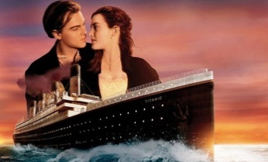 | e.  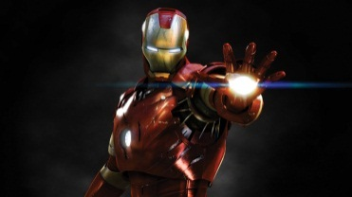
b. | f.  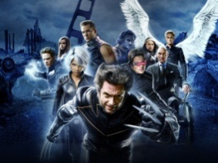
c.  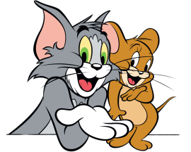 | g.  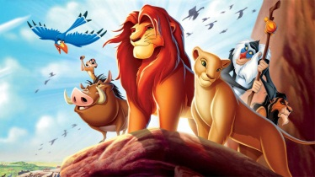
d.  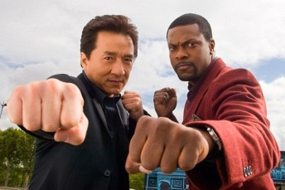 | h.
PART 2: VOCABULARY & GRAMMAR
1. Match the film titles and their plots (1-6) with the film types (a-h).
a. an animation b. a western c. a horror film d. a biopic
e. a romantic comedy f. an action film g. a sci-fi h. a thriller
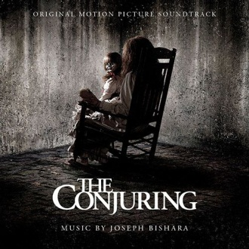  1.Paranormal investigators Ed and Lorraine Warren work to help a family terrorized by a dark presence in their farmhouse. | 4.The character first appeared in the daily King Features comic trip, Thimble Theatre, on January 17, 1929.
2.Armed with a super-suit with the astonishing ability to shrink in scale but increase in strength. | 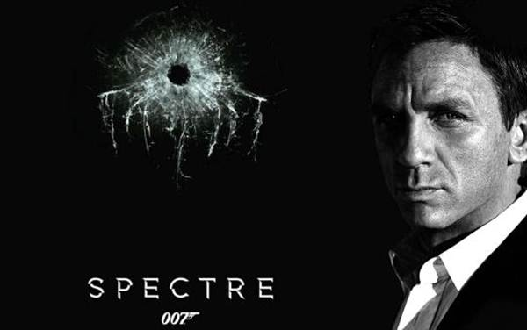  5.A cryptic message from Bond’s past sends him on a trail to uncover a sinister organization.
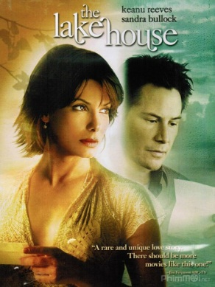  3. A lonely doctor who once occupied unusual lakeside home begins exchanging love letters with its former resident, a frustrated architect. | 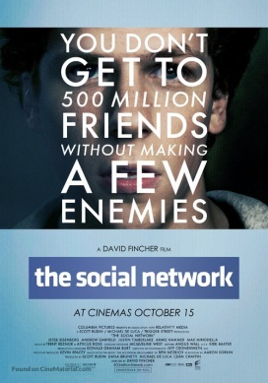  6. Harvard student Mark Zuckerberg creates the social networking site that would become known as Facebook, but is later sued by two brothers.

2. Find one odd word A, B, C or D.
1. A. terrifying B. thrilling C. fascinating D. delicious
2. A. fresh B. convincing C. believable D. interesting
3. A. excellent B. interesting C. amusing D. bad-tempered
4. A. fantastic B. wonderful C. brilliant D. lazy
5. A. dramatic B. funny C. beautiful D. boring
3. Complete the sentences with the correct form of the adjectives in brackets.
1. It's an film and I'm every time I start watching it. (interest)
2. It was in the lesson because our teacher is in history. (bore)
3. My father is very with my Math examination because of the mark. (amaze)
4. My friend is a very sort of person, but he hates doing activities. (relax)
5. Working all day is very . I get when I enter my factory. (tire)
6. We were all very about the school trip, but it wasn’t an trip at all. (excite)
4. Complete the sentences with the correct form of the adjectives in the box.
bore | excite | interest
tire | interest | bore

1. I wish this book weren't so ; I keep falling asleep whenever I try to read it.
2. "Do you think football is ?"- "Oh, I don't think so. I find table tennis is a most suitable sport for myself."
3. I'm right now. Last night I had a terrible nightmare?
4. The film was . Nothing happened.
5. Thomas was very about his new bicycle as a birthday present. He had woken up at 5 a.m. and rode the bicycle around the street.
6. This is a very book about the history of the cinema. I'm learning a lot.
5. Complete the sentences, using words in the table. Sometimes, two answers are possible.
although | despite | in spite of | however | nevertheless

1. it was raining heavily; he went out without a raincoat.
2. I heard the telephone ring, I didn't answer it.
3. I like the outdoors. , I don't like bugs and dirt.
4. her fear, she wrapped her arms around him.
5. The sky was grey and cloudy. , we went to the beach.
6. Nevertheless, many and serious shortcomings, the long series of Depretis administrations was marked by the adoption of some useful measures.
7. We have not yet won; , we shall keep trying.
8. And yet, her feelings, any relationship with him was potentially dangerous.
9. the issue was not discussed, it was far from out of her mind.
10. all Kutuzov's efforts to avoid that ruinous encounter, the massacre of the broken mob of French soldiers by worn-out Russians continued at Krasnoe for three days.
11. It looks like they're going to succeed their present difficulties.
12. being able to bench press two of her, the men actually listened.
13. she had said the words "I love you," several times, he had not uttered them.
14. Deidre felt no pity for him, the circumstances.
6. Choose best answer A, B, or C to complete the sentences.
1. It stars Marlon Brandon as the Godfather. He won an Oscar for his as the boss.
A. action B. performance C. direction
2. Shaun of the Dead is a . It's very funny, but it's also a horror film.
A. cartoon B. comedy C. sci-fi
3. There's The Princess and the Frog. It's an film from Disney.
A. ugly B. animated C. boring
4. The film was so boring. , Jack saw it from beginning to end.
A. Therefore B. However C. Although
5. If you want to know which films are on at the cinemas, you should look at thefilm of this newspaper.
A. section B. review C. report
6. I think I did OK in my speech last night I'd had almost no sleep for24 hours.
A. Although B. However C. Despite
7. My film this year was Zero Game, the latest thriller by director Xi Dong.
A. hobby B.favorite C. love
8. I couldn't sleep, being tired.
A. However B. Though C. In spite of
PART 3: READING
1. Fill in the blank with a word/ phrase in the box.
romance shot used to essential
stars fictionalized voyage imaginary
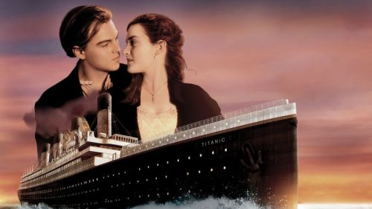
Titanic is a 1997 American epic (1) disaster film directed, written, co-produced, and co-edited by James Cameron. A (2) account of the sinking of the RMS Titanic, it (3) Leonardo DiCaprio and Kate Winslet as members of different social classes who fall in love aboard the ship during its ill-fated maiden (4) .
Cameron's inspiration for the film came from his fascination with shipwrecks; he felt a love story interspersed with the human loss would be (5) to convey the emotional impact of the disaster. Production began in 1995, when Cameron shot footage of the actual Titanic wreck. The modern scenes on the research vessel were (6) on board the Akademik Mstislav Keldysh, which Cameron had used as a base when filming the wreck. Scale models, computer-generated (7) ,and a reconstruction of the Titanic built at Playas de Rosarito in Baja California were (8) re-create the sinking. The film was partially funded by Paramount Pictures and 20th Century Fox. It was the most expensive film made at that time, with an estimated budget of $200 million.
2. Read the passage and answer the questions.
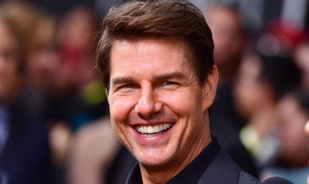
Tom Cruise (born Thomas Cruise Mapother IV; July 3, 1962) is an American actor and filmmaker. Cruise has been nominated for three Academy Awards and has won three Golden Globe Awards. He started his career at age 19 in the 1981 film Endless Love. After portraying supporting roles in Taps (1981) and The Outsiders (1983), his first leading role was in the romantic comedy Risky Business, released in August 1983.
Cruise became a full-fledged movie star after starring as Pete "Maverick" Mitchell in the action drama Top Gun (1986). One of the biggest movie stars in Hollywood, Cruise starred in several more successful films in the 1980s, including the dramas The Color of Money (1986), Cocktail (1988), Rain Man (1988), and Born on the Fourth of July (1989).
In the 1990s, he starred in a number of hit films, including the romance Far and Away (1992), the drama A Few Good Men (1992), the legal thriller The Firm (1993), the romantic horror film Interview with the Vampire: The Vampire Chronicles (1994), the romantic comedy-drama sports film Jerry Maguire (1996), the erotic thriller Eyes Wide Shut, and the drama Magnolia (both 1999). In 1996, Cruise was well known for his role as secret agent Ethan Hunt in the Mission: Impossible film series, whose most recent film, Mission: Impossible - Rogue Nation, was released in 2015.
1. What is the real name of Tom Cruise?

2. What was his first film as an actor?

3. What part did he play in Top Gun?

4. What is the type of Interview with the Vampire?

5. What is the latest film of Tom Cruise mentioned above?

3. Read the passage and put a suitable word in each of the gaps.
The advent of cinema in the late 19th (1) , and later radio and television in the 20th century broadened the access of comedians to the general public. Charlie Chaplin, through (2) film, became one of the best known faces over the (3) . The silent tradition lived on well into the 20th century through my artists like Marcel Marceau, and the physical comedy artists (4) Rowan Atkinson as Mr. Bean. The tradition of the circus clown also continued, with such as Bozo the Clown in the United States and Oleg Popov in Russia.
Radio provided new possibilities - with Britain producing the influential Goon Show after the Second World War. American cinema has produced a great (5) of globally renowned comedy artists, from Laurel and Hardy, the Three Stooges, Abbott and Costello, Dean Martin and Jerry Lewis, as well as Bob Hope during the mid-20th century, to performers like George Carlin, Robin Williams, and Eddie Murphy at the (6) of the century. Hollywood attracted many international talents like the British comics Peter Sellers, Dudley Moore and Sacha Baron Cohen, Canadian comics Dan Aykroyd, Jim Carrey, and Mike Myers, and the Australian comedian Paul Hogan, (7) for Crocodile Dundee. Other centers of creative comic activity have been the cinema of Hong Kong, Bollywood, and French farce.
American television has also been an influential force in world comedy: with American series like M*A*S*H, Seinfeld and The Simpsons achieving large followings around the world. British television comedy also remains influential with quintessential works including Fawlty Towers, Monty Python, Dad's Army, Blackadder, and The Office. Australian satirist Barry Humphries, whose comic creations include the housewife and "gigastar" Dame Edna Everage, for his delivery of Dadaist and absurdist humor to millions, was described by biographer Anne Pender in 2010 as not (8) "the most significant theatrical figure of our time ... [but] the most significant comedian to emerge since Charlie Chaplin".
end | only | silent | famous
world | like | century | number

PART 4: WRITING
1. Rearrange the words in the correct order to describe the films.
1. The Island of Dr. Moreau
place/ to/ a/ wants/ go/ where/ It’s/ no one.

2.Atlantis: The Lost Empire
Named Milo Thatch/ of Atlantis/ A team/ find/ a scientist/ of people/ the lost empire/help.

3. Hurry Potter and the Order of the Phoenix
a/It's/ do/ boy/ about/ can/ magic/ who

4. Alien
a/on/ about/ a/ lives/ monster/ spaceship/ It's/ which

5. The Incredibles
are/ are/ who/ They/ all/ family/ superheroes/ a.

6. Spider-Man 2
a/set/ USA/ science/ in/ fiction/ the/ It's/ film.

2. Read the information in the table about two actors from the UK, then write a short paragraph for each of them.
Name | Brad Pitt | Angelina Jolie
Date and place of birth | 1963, Oklahoma | 1975, California
Title of film | Legends of the Fall | Mr. & Mrs. Smith
Year(s) | 1994 | 2005
Other actors | Anthony Hopkins, Aidan Quinn, Julia Ormond and Henry Thomas | Brad Pitt

Brad Pitt was born

Angelina Jolie was born

UNIT 9: FESTIVAL AROUND THE WORLD
PART 1. PHONETICS
1. Find the word which has a different stress pattern from the other. Read the words aloud.
1. A. harvest B. famous C. design D. festival
2. A. holiday B. tradition C. vacation D. activity
3. A. outdoor B. colorful C. celebration D. movement
4. A. Monday B. flower C. occasion D. joyful
5. A. tourist B. event C. special D. national
6. A. music B. costume C. samba D. America
7. A. concert B. countryside C. concern D. lantern
8. A. surrounding B. manner C. stadium D. famous
9. A. Carnival B. party C. season D. parade
10. A. brighten B. Birthday C. delightful D. present
2. Put the following words below in the correct column according to their stress pattern.
culture enjoy envelope ancient
album lucky relative fortune
display ancestor decorate family
Muslim modern several popular
annual sacrifice lunar symbol
Stress on 1st syllable | Stress on 2nd syllable

PART 2: VOCABULARY & GRAMMAR
1. Give the names of the following then read the words aloud.
a. | e.  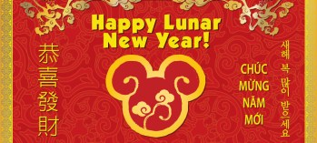
b. | f.  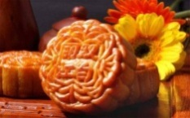
c.  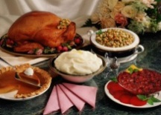 | g.  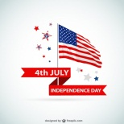
d.  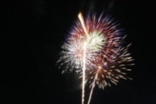 | h.
2. Find one odd word A, B, C or D.
1. A. Tet holiday B. Easter C. Thanksgiving D. Monday
2. A. tired B. joyful C. delightful D. happy
3. A. sausage B. turkey C. beef steak D. Birthday cake
4. A. candle B. lighting C. lantern D. moon
5. A. sibling B. cousin C. friend D. relative
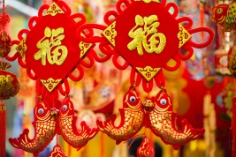
3. Make questions for the underlined parts in the following sentences, using the question words in the brackets.
A. Lunar New Year
1. New Year's Day is celebrated on the first day of the new year. (When)

2. In New Year's Eve, there are often fireworks at midnight. (What)

3. People celebrate New Year's Eve with fireworks at the stroke of midnight as the New Year starts. (How)

4. People often spend New Year with their family and relatives to remember and honor their ancestors. (Who)

5. Every family thoroughly deans the house to sweep away any ill-fortune and make way for good incoming luck. (Why)

B. Eid al-Adha (Festival of Sacrifice)
1. The festivities last for three days or more depending on the country. (How long)

2.The sacrificed animals must be at least a year old. (How old)

3. Eid al-Adha is celebrated by Muslims worldwide. (Who)

4. In the Islamic lunar calendar, Eid al-Adha falls on the 10th day of Dhu al-Hijjah and lasts for four days. (When and How long)

5. The Festival originated in the valley of Mecca (in present-day Saudi Arabia). (Where)

4. Underline adverbial phrases in following sentences.
1. We first met when he became the manager of the bank.
2. I sometimes call on my younger sister when I'm in London
3. After we had eaten, we played cards
4. Take a packed lunch with you, in case you get hungry.
5. There was a power failure earlier today and the trains are all running late now.
6. He behaved in such a silly way I was ashamed of him.
7. We served drinks as soon as our friends arrived.
8. Dad found his change between the couch cushions.
9. To track my running speed, I use a stopwatch.
10. Carter put wood in the fireplace to keep the cabin warm.
11. Christina went to the grocery store.
12. The carpenter hit the nail with a hammer.
5. Each question has a sentence with an underlined phrase. Identify what TYPE of adverb phrase this is, using definitions in the box.
Manner time purpose frequency place
1. Joe buys flowers for his wife every week.
2. Elephants are found in Africa and India.
3. I’ll meet you on Friday.
4. We hardly ever use the microwave.
5. I bought the glue to fix my broken lamp.
6. The woman stared at me with an angry expression.
7. Surfing is a popular sport in the summer.
8. Janice placed the chair next to the window.
PART 3: READING
1. Fill in the blank with a word/ phrase in the box.
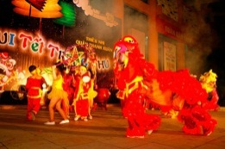
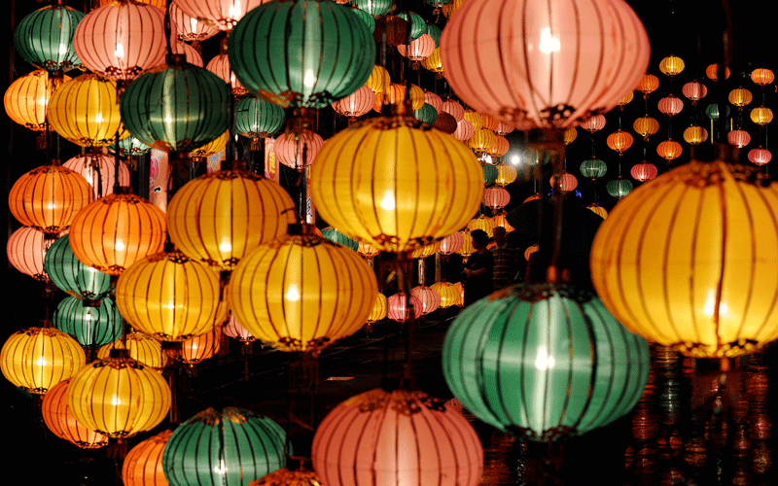
to worship the Moon Genie from a Chinese story
In the middle through years gradually

Mid-Autumn (Trung Thu) is the day when the moon is at its brightest in a year. In that spirit (1) , people in Vietnam as well as many Asian countries celebratethe Mid-Autumn's Festival. According to legends, this holiday is originated (2) in which an Emperor of Duong (Tang) Dynasty, Duong Minh Hoang, was taken to the moon by a wizard named La Cong Vien. (3) of his trip to the moon, the Emperor caught a glimpse of fairies in heaven celebrating the full moon. When Duong Minh Hoang was back to earth, he taught his citizens about the celebration and it became a custom lasting (4) . Through times and times, Mid-Autumn's Festival (5) becomes an event providing children with a rich diversity of delightful traditional games and entertaining activities, offering great helps in promoting education as well as culture.
2. Read the passage and answer the questions.
Together with Bai Dinh and Yen Tu Pagoda Festival, Huong Pagoda Festival is among the greatest Buddhist festival in northern part of Vietnam. Huong Pagoda is located in My Duc District, 70 kilometers away from Hanoi to the south. This festival lasts for three months from the first to the third month in Lunar Calendar. In fact, the official opening day for the festival is on the 6th day of the first Lunar month. As other festivals in Vietnam, Huong Pagoda Festival is also divided into two parts: The ceremonies and the entertaining activities. Ceremonial rituals consist of incense offering procession and Zen ceremony in which Monks and Buddhists offer incense, flowers, candles and fruits. During the ceremony, there are two monks performing beautiful and flexible dances. On the other hand, entertaining activities include enjoying boat cruise along Yen Stream for watching picturesque scenery, climbing mountain and exploring holy caves. It is believed that climbing up the top of Huong Tich Mountain will bring you fulfillment and great success in life.
1. Where do people celebrate Huong Pagoda Festival?

2. How long does the festival last?

3. Which part of the festival do people climb the mountain?

4. Why do people climb up the top of Huong Tich Mountain?

PART 4: WRITING
1. Arrange following phrases into a complete sentence.
1. Giong festival / different occasions / destinations / takes place in / depending on

2. Giong Festival / as an / of mankind / have been / intangible cultural heritage / recognized by UNESCO

3. Hung King / of the third Lunar month / is celebrated / Temple Festival / on the tenth day

4. Phu Tho / centuries ago / Province / where / the country /is a sacred land / Hung Kings established

5. Temple Festival / so on / in Hung King / traditional songs, chess playing, and / are/ Entertaining activities

6. Hung Kings - the country's founders / is to / worship / The purpose/ of this Festival

key:
UNIT 7: TRAFFIC
C. EXERCISES - BÀI TẬP THỰC HÀNH
PART 1. PHONETICS
1. Find the word which has a different sound in the part underlined. Read the words aloud.
1. d 2. d 3. c 4. c 5. d
6. d 7. c 8. c 9. d 10. d
2. Put the words with the underlined part in the box into two groups
/eɪ/ | /ɛ/
train, gey, railway, rain, plane | head, left, dead, wet, helicopter

3. Label the signs with the words/phrases below.
a. Watch Children  b. No Pedestrian Crossing  c. No truck  d. Right Curve Ahead | e. Right Turn  f. Right Lane Ends  g. Emergency Vehicle Warning  h. Danger Railroad Crossing

PART 2: VOCABULARY & GRAMMAR
1. Circle A, B, C or D for each picture.
1. A 2. C 3. A 4. B 5. C 6. B
2. Find one odd word A, B, C or D.
1. C 2. D 3. D 4. B 5. C
3. Put questions for the underlined parts in the following sentences, using question words in brackets.
1. How does Nam usually go to school?
2. What did your grandfather use to do in the West lake every afternoon?
3. Where are there a lot of trucks and cars in the rush hour?
4. What did the student use to be taught about when they studied in secondary school?
5. How does Hung drive his car?
6. How far is it from Ha Noi to Hai Phong?
4. Fill each blank with suitable words in the box.
1. is 2. is 3. jam 4. walked
5. are 6. use to 7. from 8. catches
9. to 10. am 11.it 12. station
5. Complete the following conversation with the sentences A-F.
1. A 2. F 3. B 4. E 5. D 6. C
6. Give the correct form of the words in brackets.
1. is 2. increasing 3. earn
4. have 5. Becoming 6. purchase

PART 3: READING
1. Fill in the blank with a word/ phrase in the box.
1. cities 2. problem 3. discourage 4. expensive
5. transport 6. Pollution 7. Example 8. Trains
2. Read the passage and answer the questions.
1. Because there was an overflow of horse-drawn traffic over Westminster Bridge.
2. the semaphore
3. Because after only a month of use the device exploded and injured the police officer who was operating the light.
4. eight feet
5. B
3. Read the passage and put a suitable word in each of the gaps
1. place 2. time 3. it 4. out
5. catch 6. takes 7. is 8. stuck
PART 4: WRITING
1. Make sentences using the words and phrases given
1. Mr Thanh didn't use to travel to Korea.
2. It is 250 km from Ho Chi Minh City to Da Nang.
3. My hometown used to be a small village.
4. How was it from Ha Noi to Singapore in the past?
5. Lana used to be on foot to school or by car?
6. He used to be a good student, but now he is poor.
2. Rewrite the following sentences so that their meaning stays the same, using the word given for each.
1. My father always drives carefully.
2. It is about 100 km from Ha Noi to Hai Phong.
3. If you aren't careful, you'll have an accident.
4. Hung used to go to his homeland by train some years ago, but now he drives his car.
5. Traffic rules should be obeyed strictly by road users.
6. Can we travel to Korea by car?
7. There are buses leaving for Hai Phong every 15 minutes from 6 a.m to 10 p.m.
8. My family used to be very poor, but we have 100 million USD now.

UNIT 8: FILMS
C. EXERCISES - BÀI TẬP THỰC HÀNH
PART 1. PHONETICS
1. Find the word which has a different sound in the part underlined. Read the words aloud.
1. c 2. b 3. d 4. c 5. c
6. c 7. a 8. b 9. b 10. a
2. Put the words with the underlined part in the box into three groups.
/t/ | /d/ | /id/
brushed  matched  washed  shocked  stopped  laughed  touched  looked | volunteered  raised  tagged  convinced  moved  pleased  appeared | needed  decided  fascinated  interested  treated

3. Give the names of the following films, then read the words aloud.
a. Titanic b. Superman c. Tom and Jerry d. Rush hour
e. Ironman f. X-Men g. Lion King h. Mickey
PART 2: VOCABULARY & GRAMMAR
1. Match the film titles and their plots (1-6) with the film types (a-h)
1. c 2. e 3. g 4. a 5. f 6. d
2. Find one odd word A, B, C or D.
1. D 2. A 3. D 4. D 5. C
3. Complete the sentences with the correct form of the adjectives in brackets.
1. interesting/ interested
2. bored/ boring
3. amazed/ amazing
4. relaxing/ relaxing
5. tired/ tired
6. excited/ exciting
4. Complete the sentences with the correct form of the adjectives in the box.
1. boring 2. Interesting 3. tired
4. boring 5. Excited 6. interesting
5. Complete the sentences, using words in the table. Sometimes, two answers are possible.
1. Although 2. Although 3. However 4. Despite
5. Nevertheless 6. in spite of 7. However 8. despite
9. Although 10. Despite 11. in spite of 12. In spite of
13. Although 14. Despite
6. Choose best answer A, B, or C to complete the sentences.
1. B 2. B 3. B 4. B
5. A 6. A 7. B 8. C
PART 3: READING
1. Fill in the blank with a word/ phrase in the box.
1. romance 2. fictionalized 3. stars 4. voyage
5. essential 6. Shot 7. Imaginary 8. used to
2. Read the passage and answer the questions.
1. Thomas Cruise Mapother IV
2. The 1981 film Endless Love
3. Pete "Maverick" Mitchell
4. The romantic horror film
5. Mission: Impossible - Rogue Nation
3. Read the passage and put a suitable word in each of the gaps.
1. century 2. silent 3. world 4. like
5. number 6. End 7. Famous 8. only
PART 4: WRITING
1. Rearrange the words in the correct order to describe the films.
1. It's a place where no one wants to go.
2. A team of people help a scientist named Milo Thatch find the lost empire of Atlantis.
3. It's about a boy who can do magic.
4. It's about a spaceship on which a monster lives.
5. They are superheroes who all are a family.
6. It's a science fiction film set in the USA.

5. Entertaining activities in Hung King Temple Festival are traditional singings, chess playing, and so on.
6. The purpose of this Festival is to worship Hung Kings - the country's founders.
UNIT 9: FESTIVAL AROUND THE WORLD
C. EXERCISES - BÀI TẬP THỰC HÀNH
PART 1. PHONETICS
1. Find the word which has a different stress pattern from the other. Read the words aloud.
1. c 2. a 3. c 4. c 5. b
6. d 7. c 8. a 9. d 10. c
2. Put the following words below in the correct column according to their stress pattern.
Stress on 1st syllable | Stress on 2nd syllable
culture Muslim  envelope modern  ancient several  album popular  lucky annual  relative sacrifice  fortune lunar  decorate symbol  family ancestor | enjoy  display

PART 2: VOCABULARY & GRAMMAR
1. Give the names of the following then read the words aloud.
a. Christmas e. Lunar New Year/Tet holiday
b. present f. Mid-Autumn Festival
c. feast/ party g. Independence Day
d. fireworks h. turkey
2. Find one odd word A, B, C or D.
1. D 2. A 3. D 4. D 5. C
3. Make questions for the underlined parts in the following sentences, using the question words in the brackets.
A. Chinese New Year
1. When is New Year's Day celebrated?
2. What often happens in New Year's Eve?
3. How do People celebrate New Year's Eve?
4. Who do people often spend New Year with?
5. Why does every family thoroughly clean the house in New Year?
B. Eid al-Adha (Festival of Sacrifice)
1. How long do the festivities last?
2. How old are the sacrificed animals?
3. Who celebrates Eid al-Adha?
4. When and how long is the Eid al-Adha?
5. Where did the Festival originate?
4. Underline adverbial phrases in following sentences
1. We first met when he became the manager of the bank.
2. I sometimes call on my younger sister when I'm in London.
3. After we had eaten, we played cards.
4. Take a packed lunch with you, in case you get hungry.
5. There was a power failure earlier today and the trains are all running late now.
6. He behaved in such a silly way I was ashamed of him.
7. We served drinks as soon as our friends arrived.
8. Dad found his change between the couch cushions.
9. To track my running speed, I use a stopwatch.
10. Carter put wood in the fireplace to keep the cabin warm.
11. Christina went to the grocery store.
12. The carpenter hit the nail with a hammer.
5. Each question has a sentence with an underlined phrase. Identify what TYPE of adverb phrase this is, using definitions in the box.
1. frequency 2. place 3. time 4. frequency
5. purpose 6. Manner 7. Time 8. place
PART 3: READING
1. Fill in the blank with a word/ phrase in the box.
1. to worship the Moon Genie 2. from a Chinese story
3. In the middle 4. through years
5. gradually
2. Read the passage and answer the questions.
1. in My Duc District (70 kilometers away from Hanoi to the south)
2. three months
3. the entertaining activities
4. Because it is believed to bring people fulfillment and great success in life
PART 4: WRITING
1. Arrange following phrases into a complete sentence
1. Giong festival takes place in different occasions depending on destinations.
2. Giong Festival have been recognized by UNESCO as an intangible cultural heritage of mankind.
3. Hung King Temple Festival is celebrated cm the tenth day of the third Lunar month.
4. Phu Tho Province is the sacred land where Hung Kings established the country centuries ago.
5. Entertaining activities in Hung King Temple Festival are traditional singings, chess playing, and so on.
6. The purpose of this Festival is to worship Hung Kings - the country's founders.
UNIT 9: FESTIVAL AROUND THE WORLD
C. EXERCISES - BÀI TẬP THỰC HÀNH
PART 1. PHONETICS
1. Find the word which has a different stress pattern from the other. Read the words aloud.
1. c 2. a 3. c 4. c 5. b
6. d 7. c 8. a 9. d 10. c
2. Put the following words below in the correct column according to their stress pattern.
Stress on 1st syllable | Stress on 2nd syllable
culture Muslim  envelope modern  ancient several  album popular  lucky annual  relative sacrifice  fortune lunar  decorate symbol  family ancestor | enjoy  display

PART 2: VOCABULARY & GRAMMAR
1. Give the names of the following then read the words aloud.
a. Christmas e. Lunar New Year/Tet holiday
b. present f. Mid-Autumn Festival
c. feast/ party g. Independence Day
d. fireworks h. turkey
2. Find one odd word A, B, C or D.
1. D 2. A 3. D 4. D 5. C
3. Make questions for the underlined parts in the following sentences, using the question words in the brackets.
A. Chinese New Year
1. When is New Year's Day celebrated?
2. What often happens in New Year's Eve?
3. How do People celebrate New Year's Eve?
4. Who do people often spend New Year with?
5. Why does every family thoroughly clean the house in New Year?
B. Eid al-Adha (Festival of Sacrifice)
1. How long do the festivities last?
2. How old are the sacrificed animals?
3. Who celebrates Eid al-Adha?
4. When and how long is the Eid al-Adha?
5. Where did the Festival originate?
4. Underline adverbial phrases in following sentences
1. We first met when he became the manager of the bank.
2. I sometimes call on my younger sister when I'm in London.
3. After we had eaten, we played cards.
4. Take a packed lunch with you, in case you get hungry.
5. There was a power failure earlier today and the trains are all running late now.
6. He behaved in such a silly way I was ashamed of him.
7. We served drinks as soon as our friends arrived.
8. Dad found his change between the couch cushions.
9. To track my running speed, I use a stopwatch.
10. Carter put wood in the fireplace to keep the cabin warm.
11. Christina went to the grocery store.
12. The carpenter hit the nail with a hammer.
5. Each question has a sentence with an underlined phrase. Identify what TYPE of adverb phrase this is, using definitions in the box.
1. frequency 2. place 3. time 4. frequency
5. purpose 6. Manner 7. Time 8. place
PART 3: READING
1. Fill in the blank with a word/ phrase in the box.
1. to worship the Moon Genie 2. from a Chinese story
3. In the middle 4. through years
5. gradually
2. Read the passage and answer the questions.
1. in My Duc District (70 kilometers away from Hanoi to the south)
2. three months
3. the entertaining activities
4. Because it is believed to bring people fulfillment and great success in life
PART 4: WRITING
1. Arrange following phrases into a complete sentence
1. Giong festival takes place in different occasions depending on destinations.
2. Giong Festival have been recognized by UNESCO as an intangible cultural heritage of mankind.
3. Hung King Temple Festival is celebrated cm the tenth day of the third Lunar month.
4. Phu Tho Province is the sacred land where Hung Kings established the country centuries ago.
5. Entertaining activities in Hung King Temple Festival are traditional singings, chess playing, and so on.
6. The purpose of this Festival is to worship Hung Kings - the country's founders.

